
Engineering for everyday world

Ace Engineer

Project Data Flow
GoM Wells

15-Nov-2012 | 01 | Added new features |  |  |  |  | VA | ?? | VA
DATE | REV | DESCRIPTION |  |  |  |  | ORIG | CHK | APPR
DOCUMENT CONTROL NO |  | Project | Type | Area | Client | - | - | Sequence | Revision
 |  |  |  | - | - | - | -

Revision History:

REV | DATE | DESCRIPTION | ORIG | CHK | APPR

Change Log

REV | SECTION | CHANGE DESCRIPTION

Document Holds
Hold | DESCRIPTION

CONTENTS
1 Introduction 4
1.1 Document Purpose 4
2 METHODOLOGY 4
2.1 2.1 Summary 4
2.2 2.2 Data Sources 4
2.2.1 BOEM 4
3 DATA GATHERING 4
3.1 Geological prospects data 4
3.1.1 Paleogene wells data 4
4 Data Analysis 5
4.1 Paleo wells identification 5
4.1.1 Output 6
4.2 Paleogene Field Names data sorting 7
4.2.1 Output 8
4.3 Paleo wells visualization 9
4.3.1 Output 10
4.4 Flow Chart Analysis 11

Introduction

Document Purpose
The purpose of this document is to detail all the basic information of Gulf of Mexico (lower tertiary wells) and provides the methodology of the system and the analysis and modules used for plotting wells geospatially.

METHODOLOGY

2.1 Summary
The key methodology steps are given below:
• Take data from data sources
• Automate where possible
• A standard scheduler can be used to

2.2 Data Sources
Data can be obtained from:
• BOEM

BOEM
The Bureau of Ocean Energy Management (BOEM) is an agency within the United States Department of the Interior established in 2010 by secretarial order and its mission is to manage development of U.S. Outer Continental Shelf energy and mineral resources in an environmentally and economically responsible way.

DATA GATHERING

Geological prospects data
Study and understanding the geological prospects of GoM region understanding the geological time scale

https://www.data.boem.gov/Paleo/Files/biochart.pdf/

Paleogene wells data
https://www.data.boem.gov/Main/Paleo.aspx/

Data Analysis
Python scripting for lower tertiary wells.

Paleo wells identification

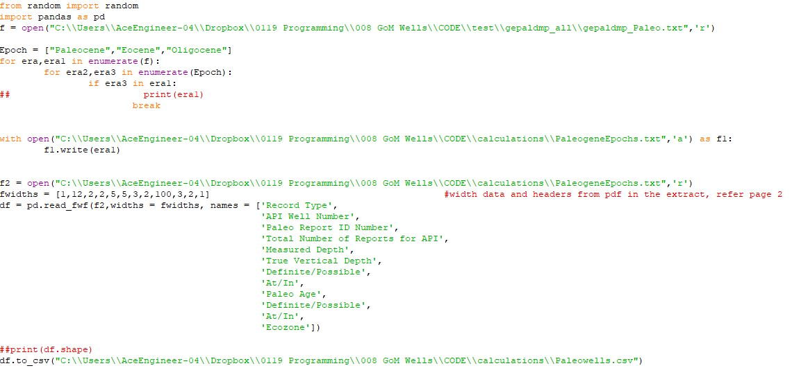

Output
A text file consisting of Lower tertiary epoch’s data

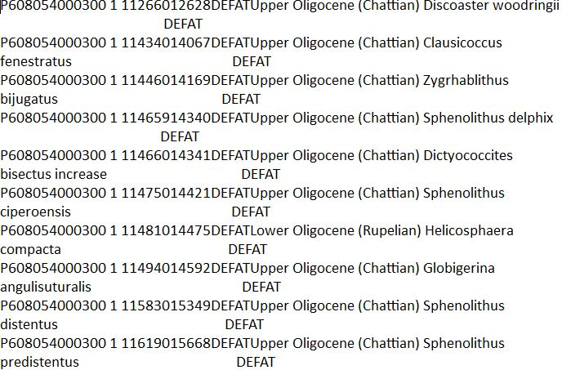

Csv file with consisting of well API number data of Paleogene era.

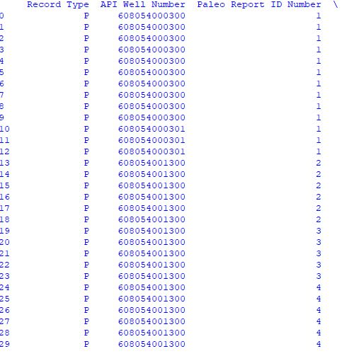
Identify Field name by API number as base from Paleo Identification

Paleogene Field Names data sorting

Field Name
 | A unique well identification number
  API Well NumberDefinition
Bottom Lease Number | The number assigned to the lease that contains the bottom location of a well.
Bottom Area Code | The designated abbreviation assigned to Outer Continental Shelf (OCS)  geographical units for identification purposes and for use on maps and  In data bases as applied to the Bottom hole location of a well.
Bottom Block Number | Identifies a subdivision of an Official Protraction Diagram as applied to  The subdivision containing the bottom hole location of a well.
Company Name | Operator name
Borehole status condition | Indicates the conditions relating to a borehole.
Latitude | The latitude value of a location in the borehole.
Longitude | The longitude value of a location in a borehole.

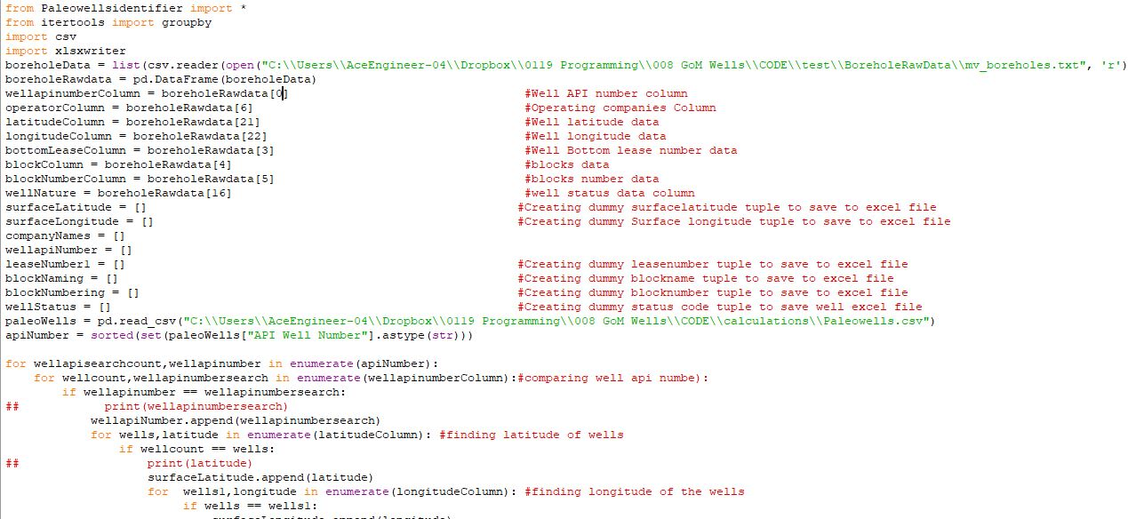

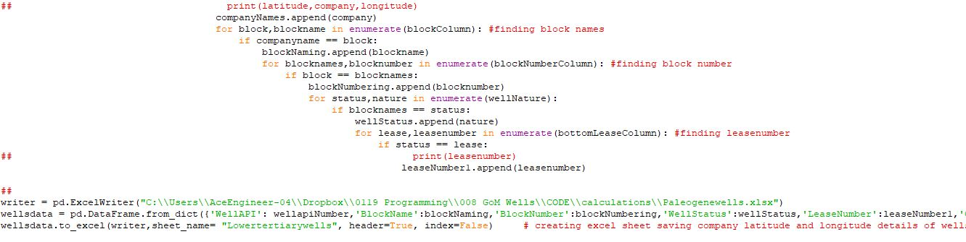

Output
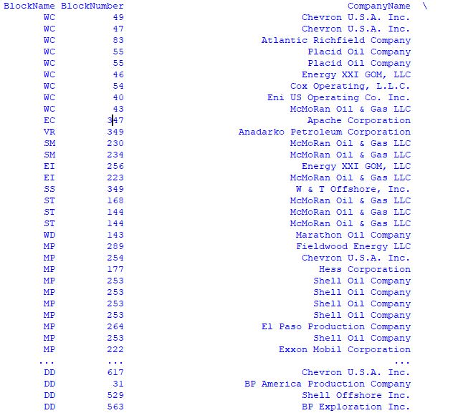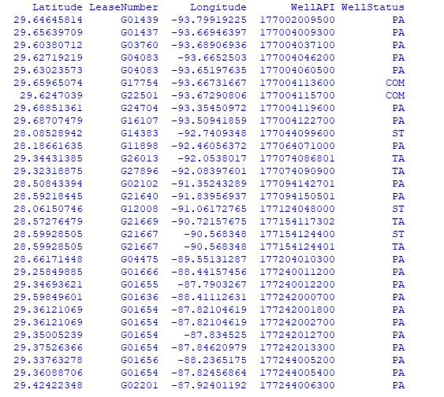

Paleo wells visualization
Lower tertiary wells by folium module

Python scripting

Reference: https://georgetsilva.github.io/posts/mapping-points-with-folium/
https://www.youtube.com/watch?v=Yd5oEIBFQ_E/
https://www.youtube.com/watch?v=2u-KFbRX44I/

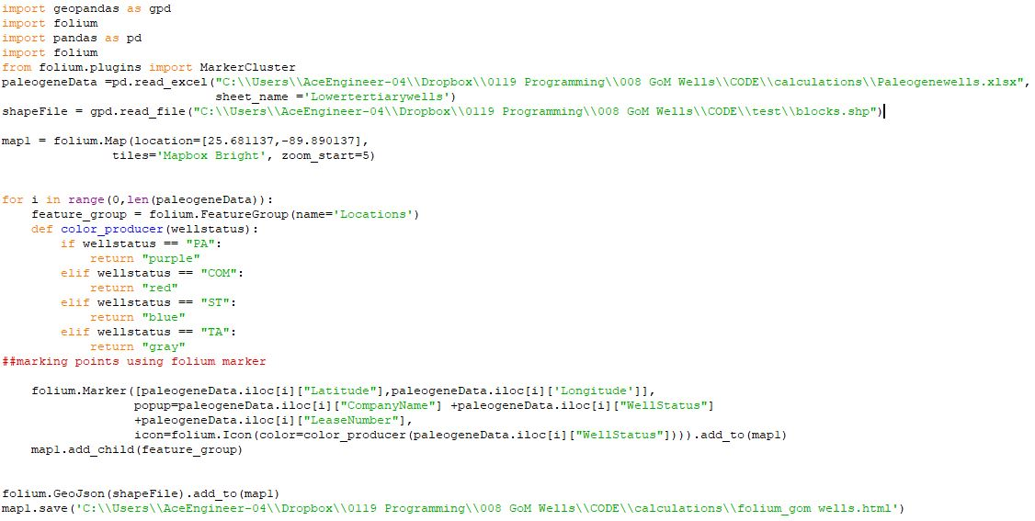

Output
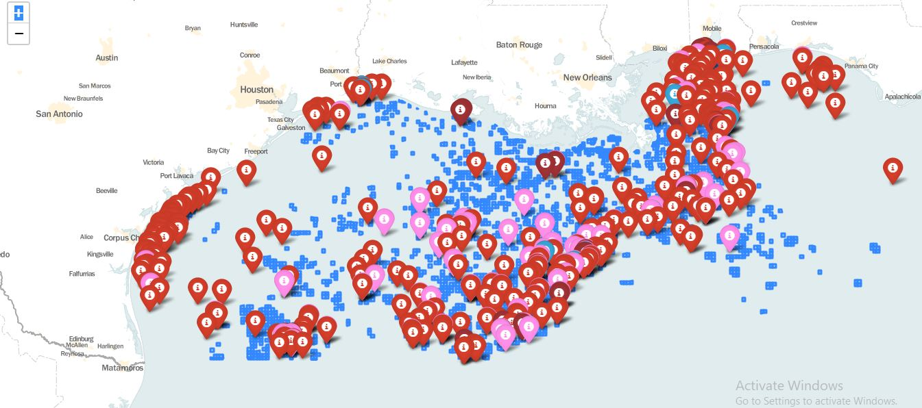

Flow Chart Analysis
Collection of Paleogene
era data
https://www.data.bsee.gov/Well/Borehole/Default.aspx/
https://www.data.boem.gov/Main/Paleo.aspx/
Collection of lower tertiary Field Names data
Resource classification
Python script for sorting Lower tertiary wells by using Well API Number
Geological time scale Study
GIS python for lower tertiary wells
Data analysis
Gulf of Mexico wells
Data flow

